**Lab S1 - ChatGPT + Enterprise data with Azure OpenAI and Cognitive Search**

This sample demonstrates a few approaches for creating ChatGPT-like experiences over your own data using the Retrieval Augmented Generation pattern. It uses Azure OpenAI Service to access the ChatGPT model (gpt-35-turbo), and Azure Cognitive Search for data indexing and retrieval.

The repo includes sample data so it's ready to try end to end. In this sample application we use a fictitious company called Contoso Electronics, and the experience allows its employees to ask questions about the benefits, internal policies, as well as job descriptions and roles.

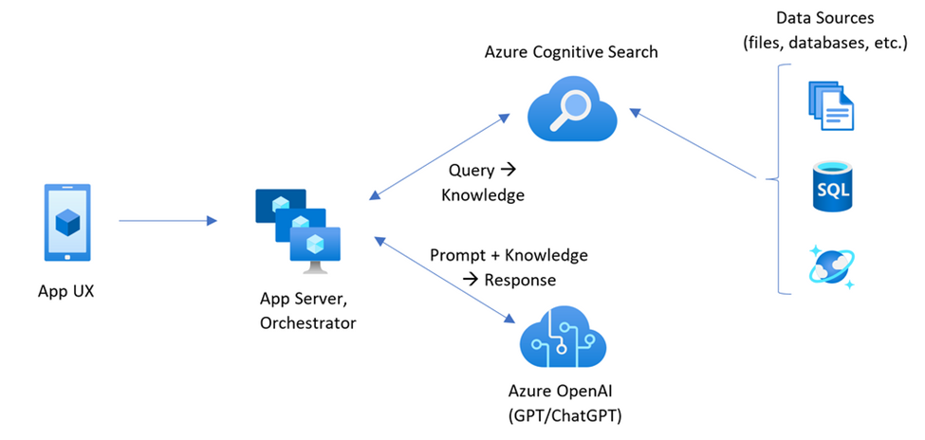

**Task 1: Update App Installer**

1. Click on the following link: **https://aka.ms/getwingetpreview**.
2. Select the **Downloads** tab, then click on **Microsoft.DesktopAppInstaller**

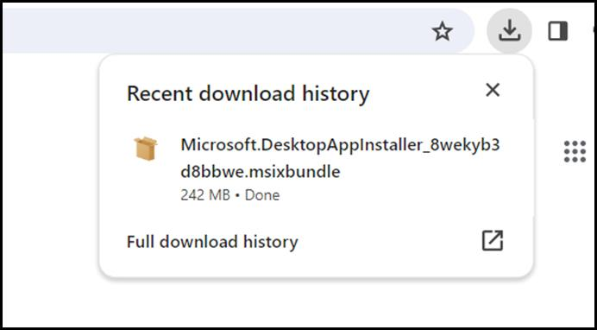

1. Open the downloaded file and click on the **Update** button to **Update App Installer**.

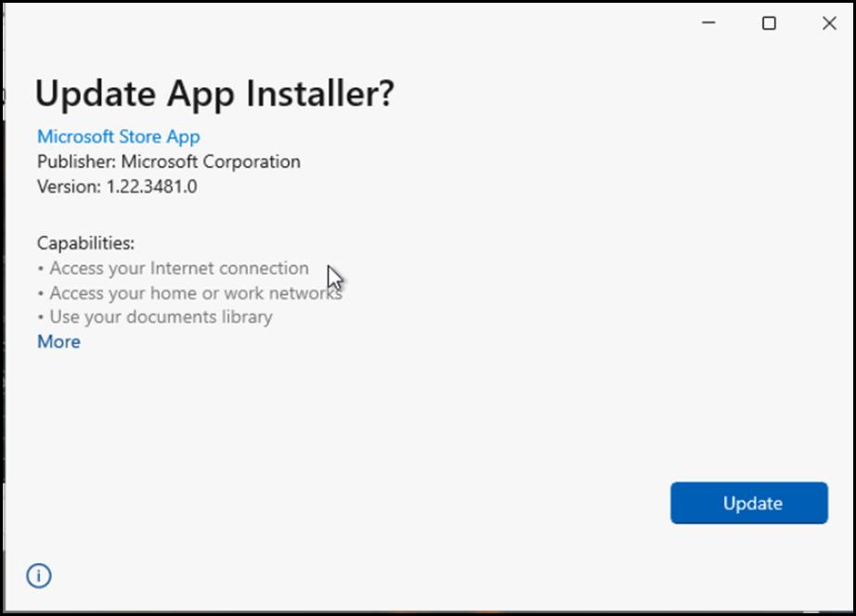

**Task 2: Install Azure Cli and set the policy scope to Local machine**

1. In your windows search bar, type **PowerShell**. In the **PowerShell** dialog box, navigate and click on **Run as administrator**. If you see the dialog box - **Do you want to allow this app to make changes to your device?** then click on the **Yes** button.

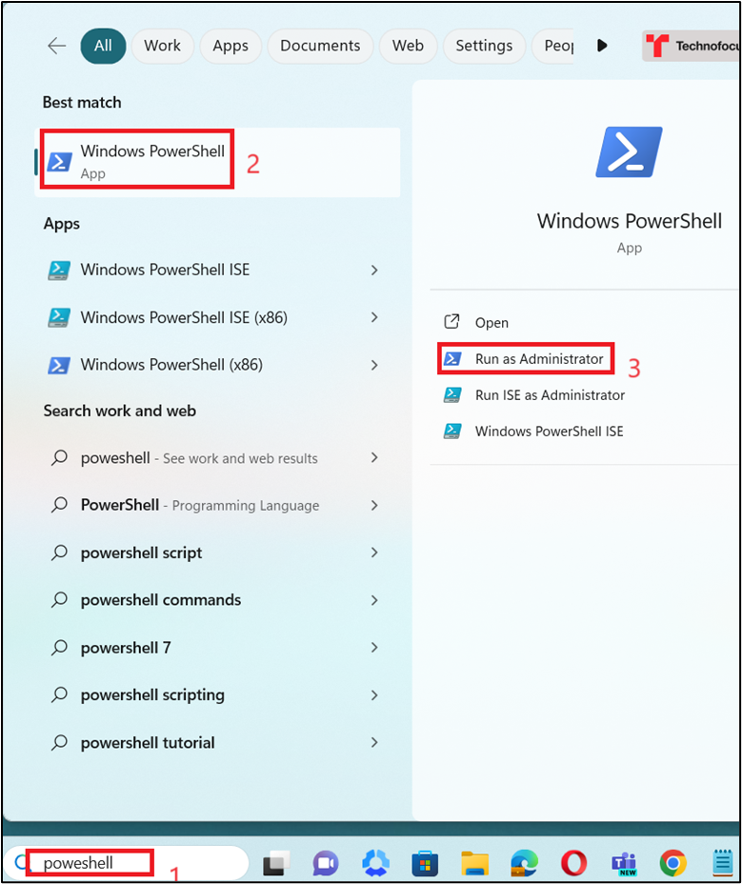

1. Run the following command to install Azure Cli on the PowerShell

powershell

winget install microsoft.azd

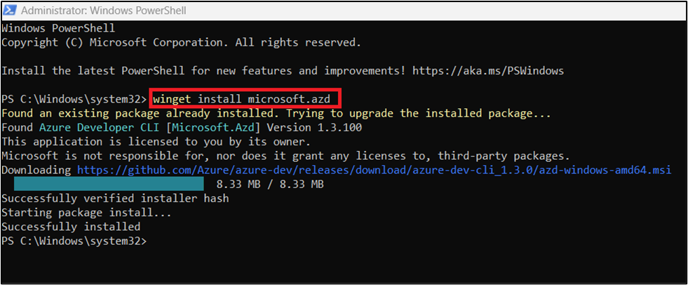

1. Run the following commands to set the policy scope to Local machine

powershell

Set-ExecutionPolicy -Scope CurrentUser -ExecutionPolicy Unrestricted

powershell

Set-ExecutionPolicy – ExecutionPolicy Unrestricted-Scope LocalMachine

powershell

Set-ExecutionPolicy – ExecutionPolicy Unrestricted-Scope Process

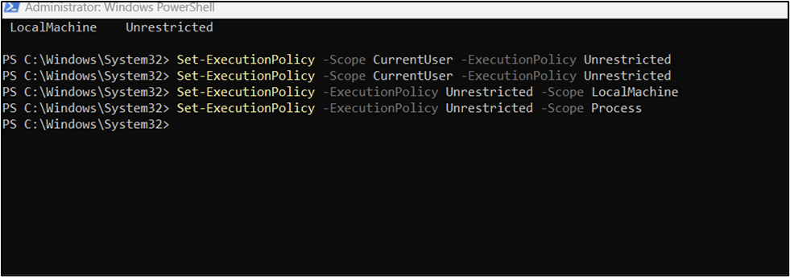

**Task 3: Install Node.js**

1. Open your browser, navigate to the address bar, type or paste the following URL:https://nodejs.org/en/download/ then press the **Enter** button. 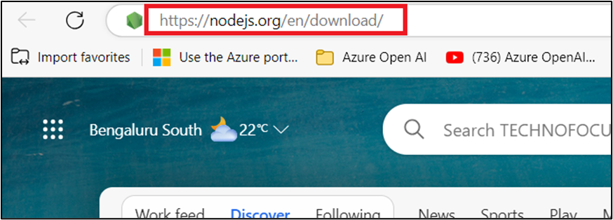
2. Select and click on **Windows Installer**.

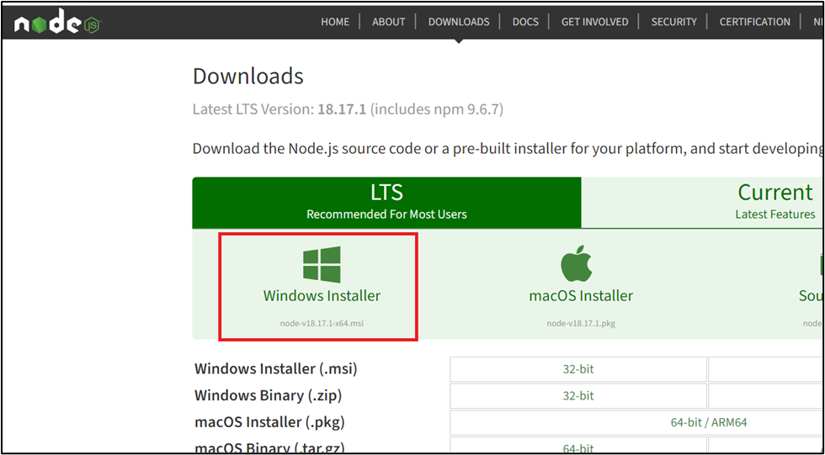

1. **Node-V** file will be downloaded. Click on the downloaded file to set up **Node.js**

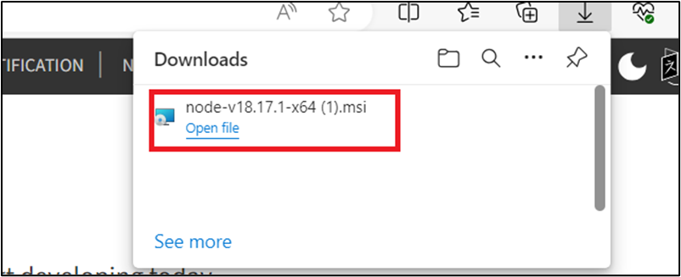

1. In the **Welcome to the Node.js Setup Wizard** window, click on the **Next button**.

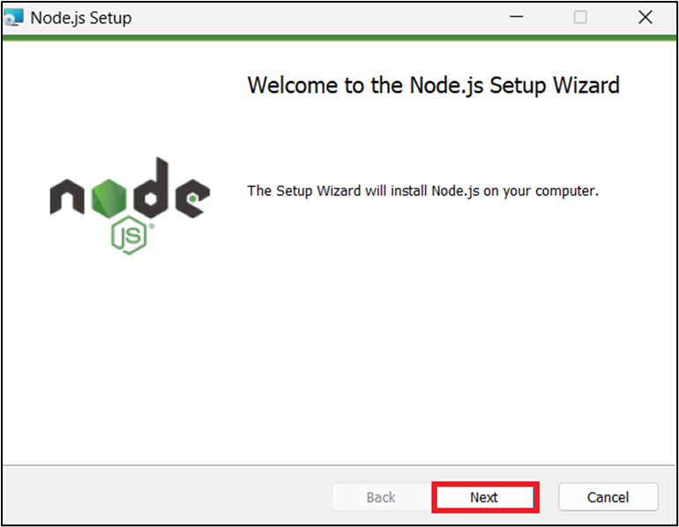

1. In the **End-User License Agreement** window, select **I accept the terms in the License agreement** radio button and click on the **Next** button.

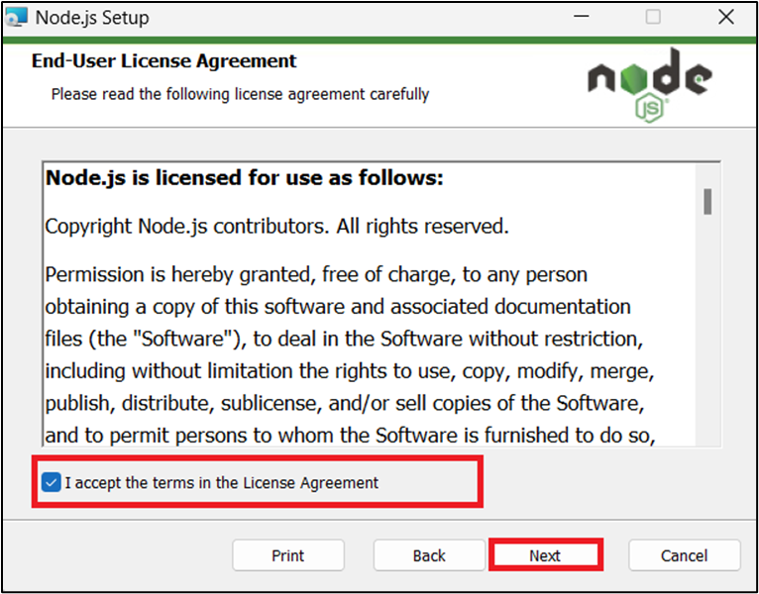

1. In the **Destination Folder** window, click on the **Next** button.

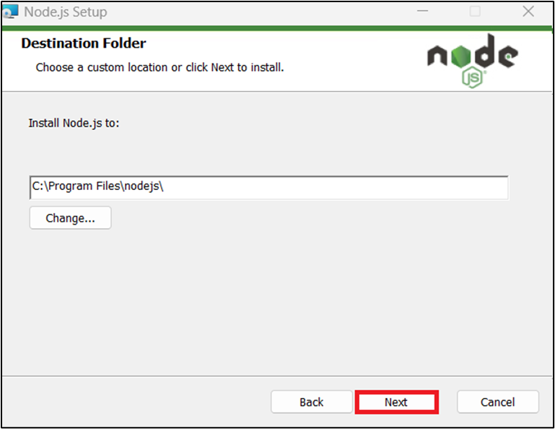

1. In the **Custom Setup** window, click on the **Next** button.

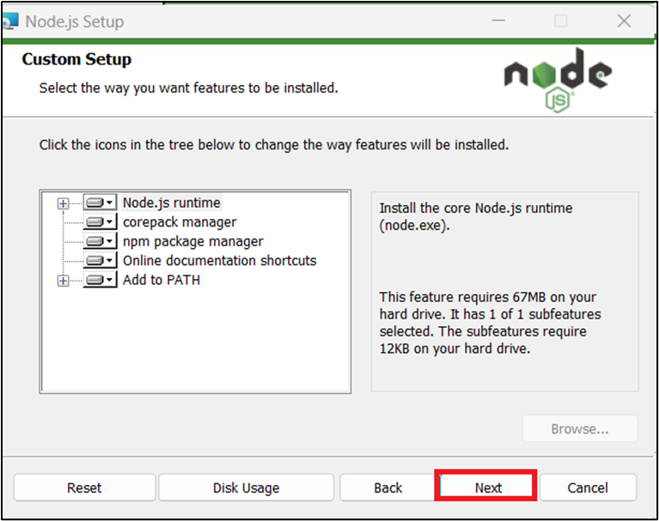

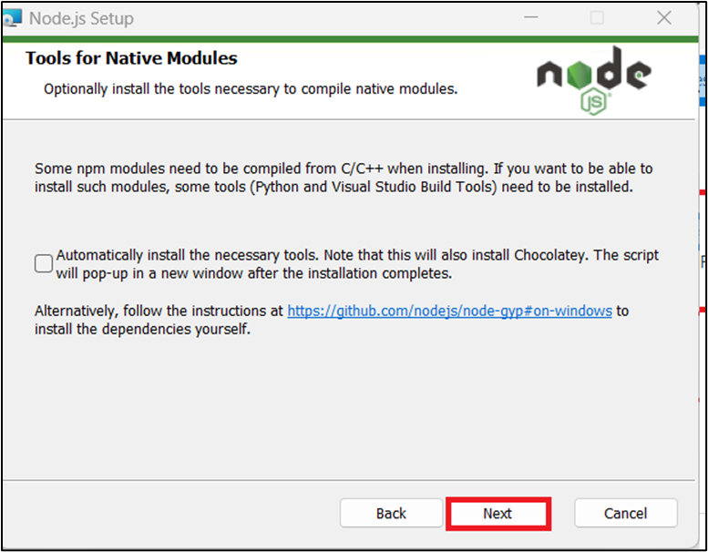

1. In Ready to install Node.js window, click on **Install.**

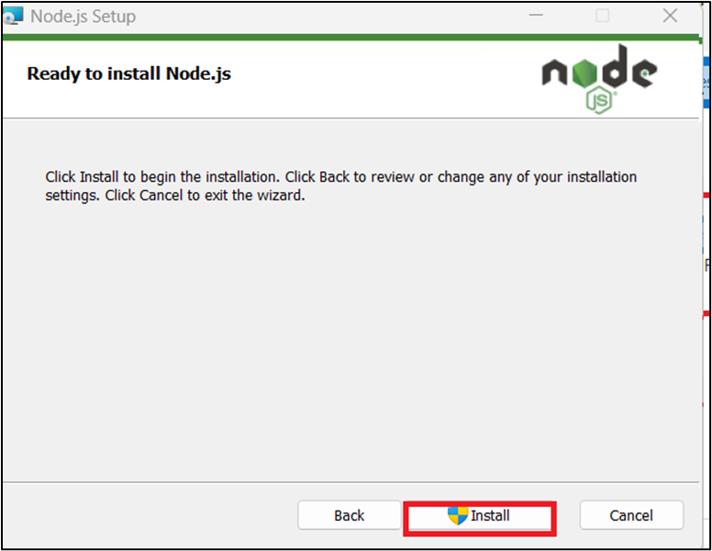

1. In **Completing the Node.js Setup Wizard window**, click on the **Finish** button to complete the installation process.

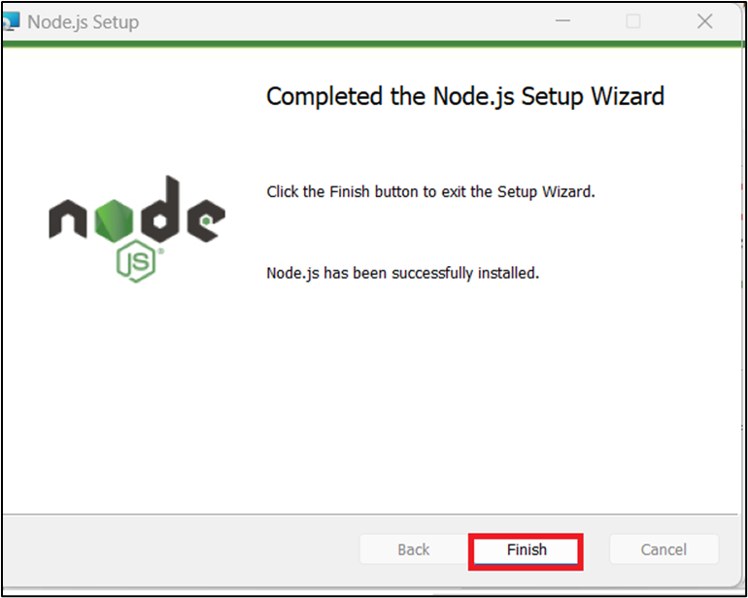

**Task 4: Assign a user as an owner of an Azure subscription**

1. Open your browser, navigate to the address bar, and type or paste the following URL:https://portal.azure.com/, then press the **Enter** button.

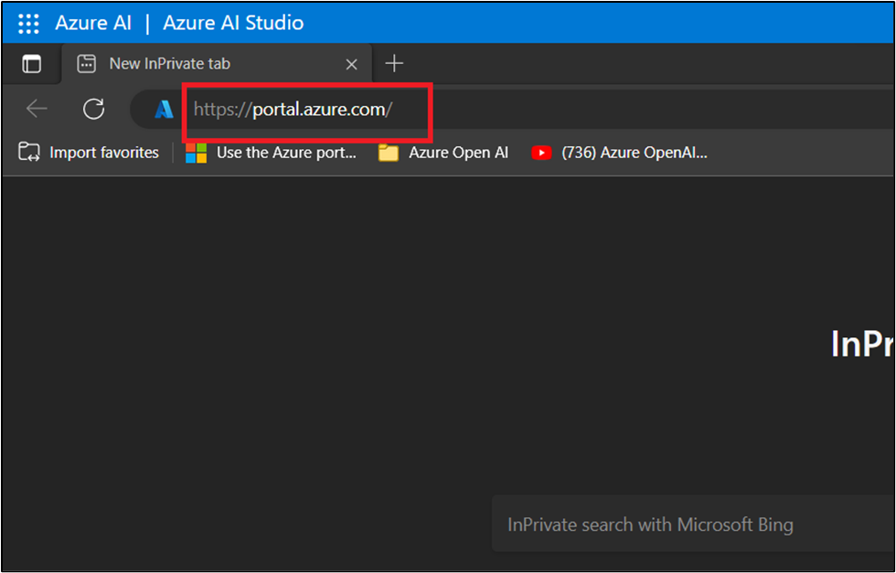

1. In the **Microsoft Azure** window, use the **User Credentials** to login to Azure.

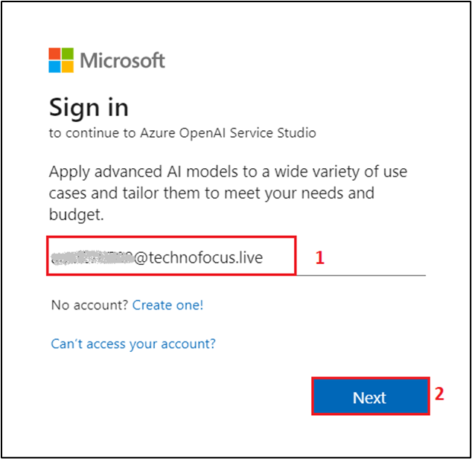

1. Then, enter the password and click on the **Sign in** button.

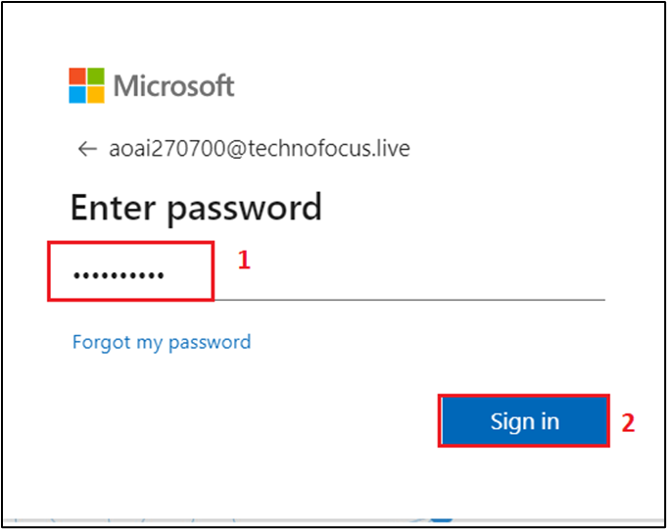

1. In **Stay signed in?** window, click on the **Yes** button.

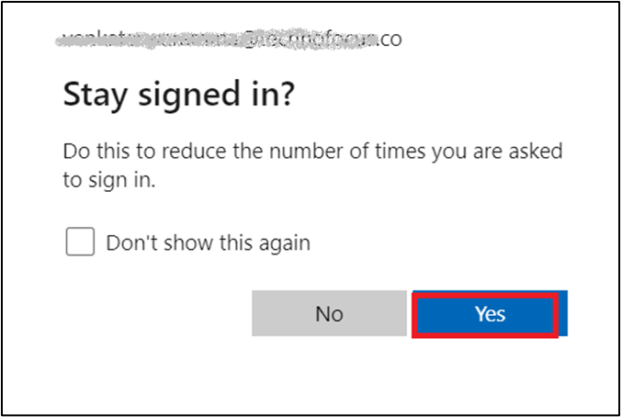

1. Type in **Subscriptions** in the search bar and select **Subscriptions**.

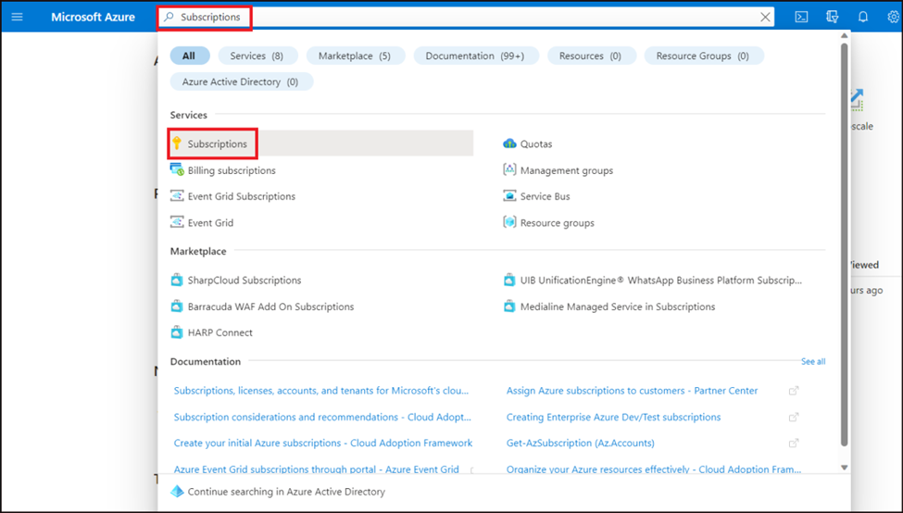

1. Click on your assigned **subscription**.

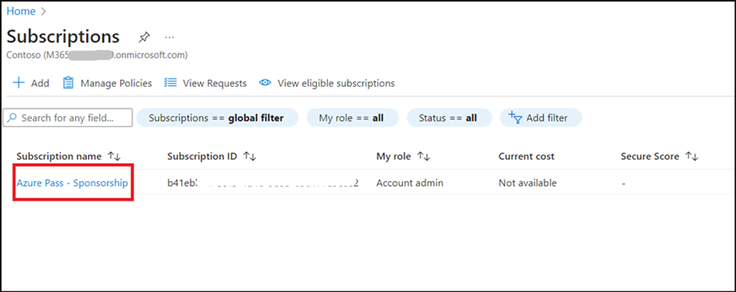

1. From the left menu, click on the **Access control(IAM).**

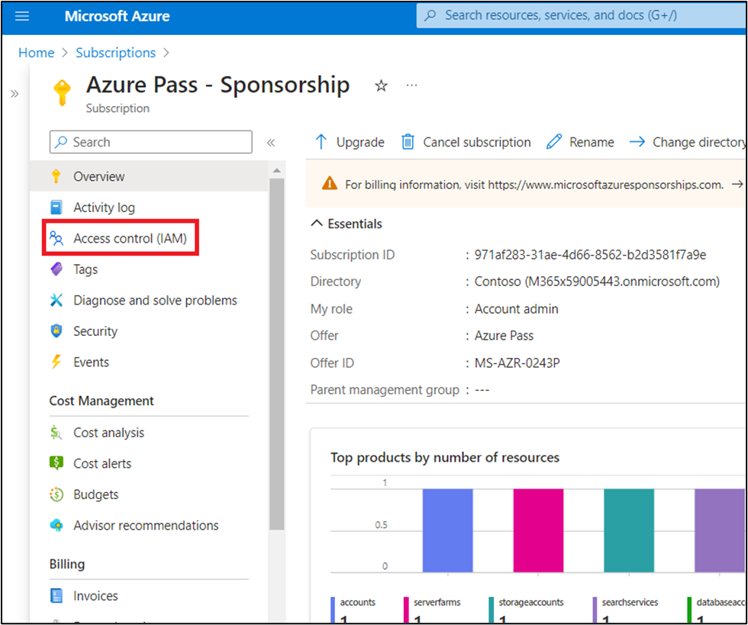

1. On the Access control(IAM) page, Click +**Add** and select **Add role assignments.**

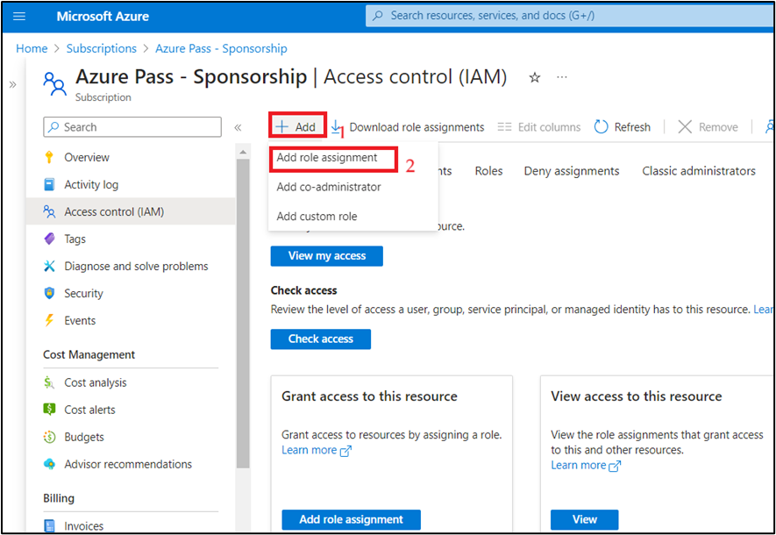

1. In the Role tab, select the **Privileged administrator roles** and select **Owner** . Click **Next**

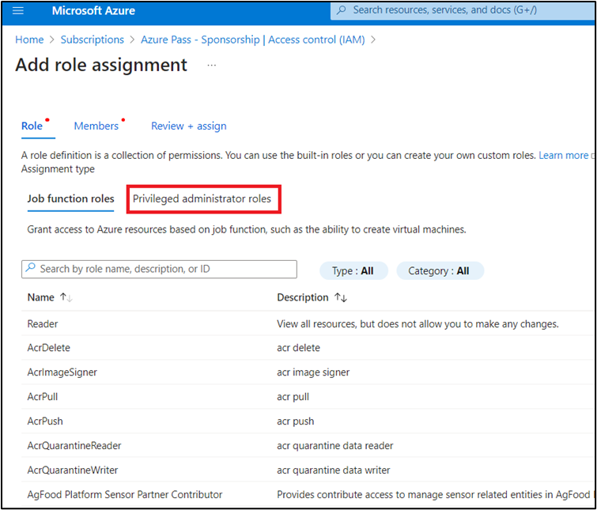

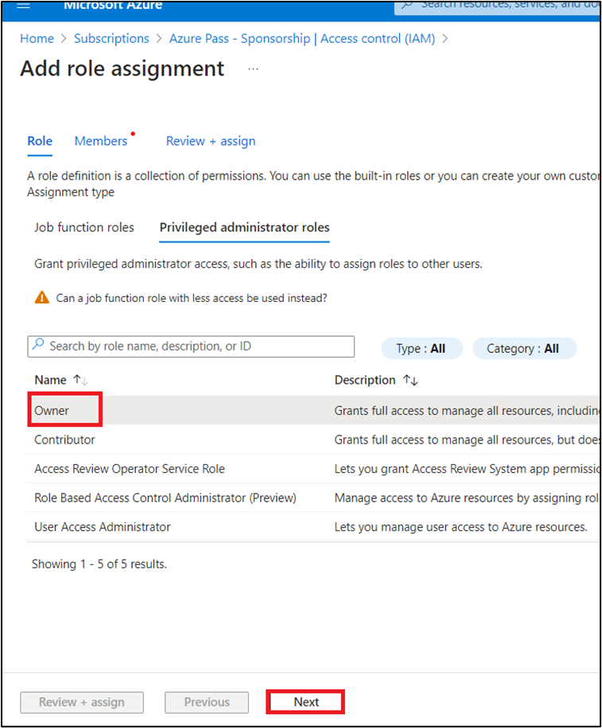

1. In the **Add role assignment** tab, select Assign access to User group or service principal. Under Members, click **+Select members**

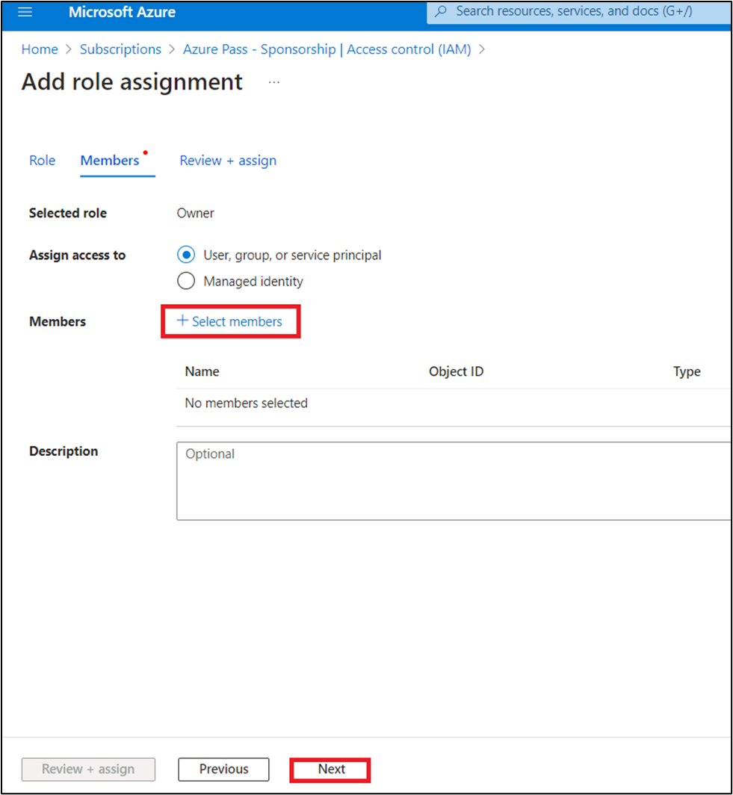

1. On the Select members tab , select your Azure OpenAI subscription and click **Select.**

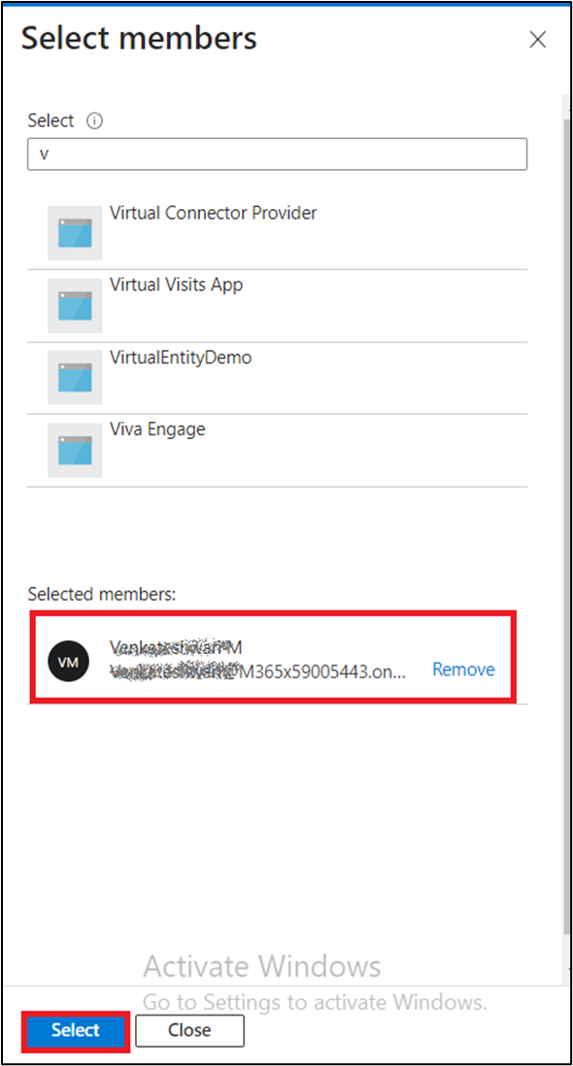

1. In the **Add role assignment** page, Click **Review + Assign**, you will get a notification once the role assignment is complete.

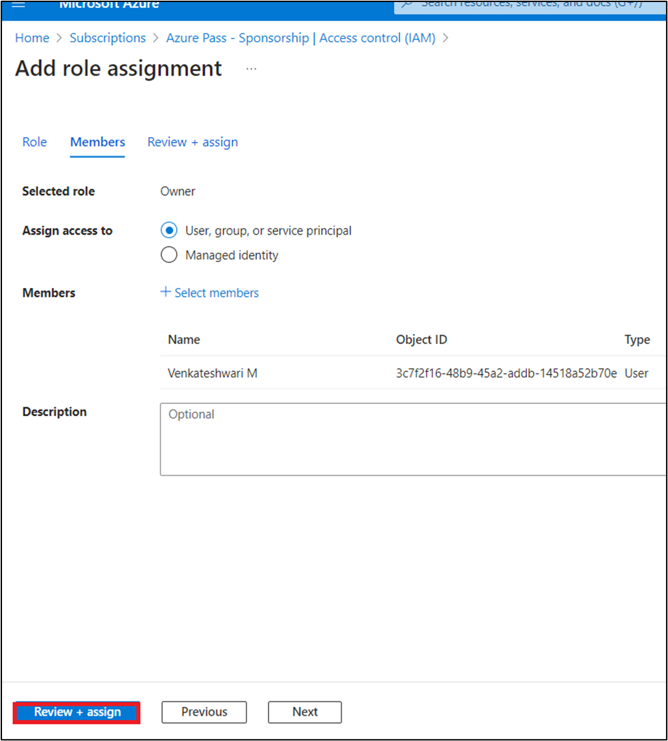

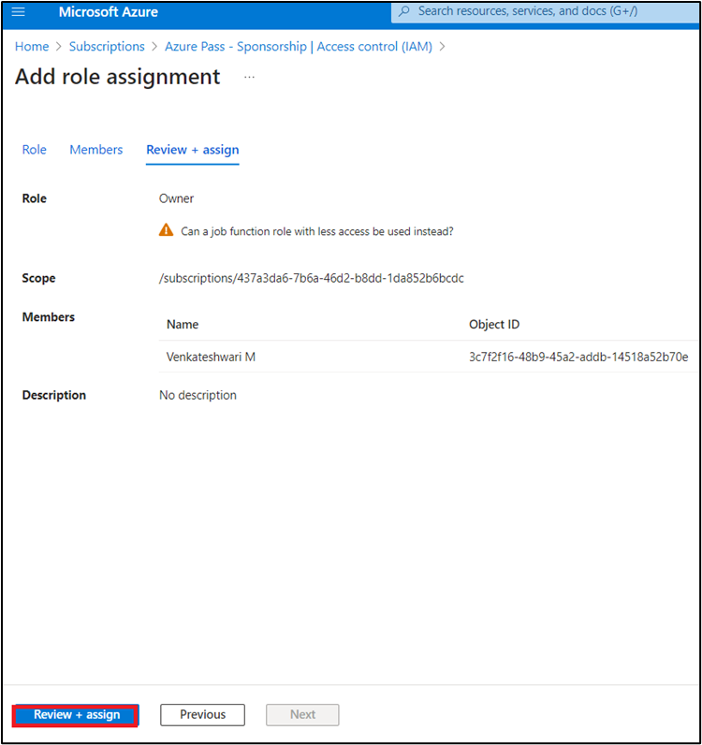

1. You will see a notification -- added as Owner for Azure Pass-Sponsorship.

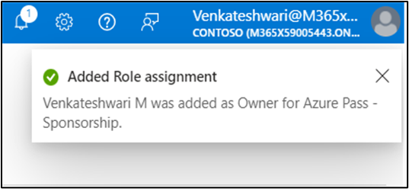

**Task 5: Bring down the project code**

1. In your windows search bar, type **Command Prompt**. In the **Command Prompt App** dialog box, navigate and click on **Run as administrator**. If you see the dialog box - **Do you want to allow this app to make changes to your device?** then click on the **Yes** button.

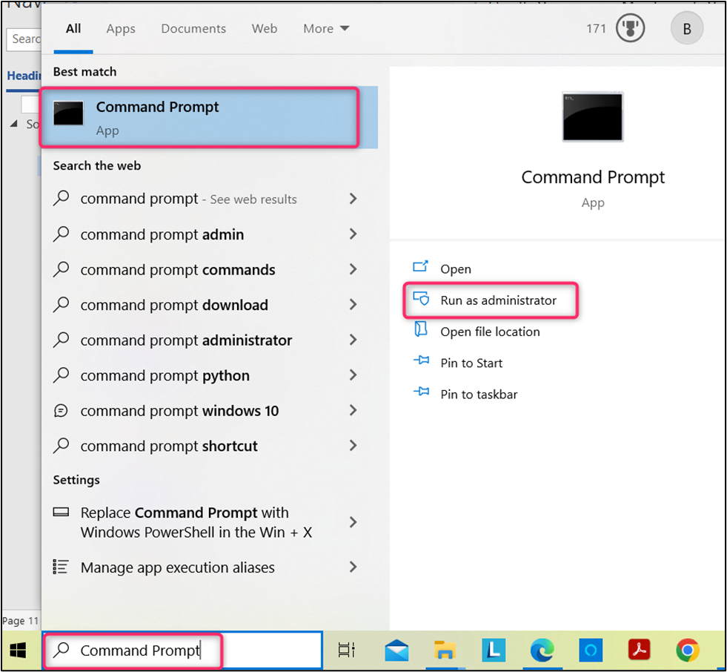

1. On **Do you want to allow this app to make changes to your device?** dialog box, click on **Yes** button.

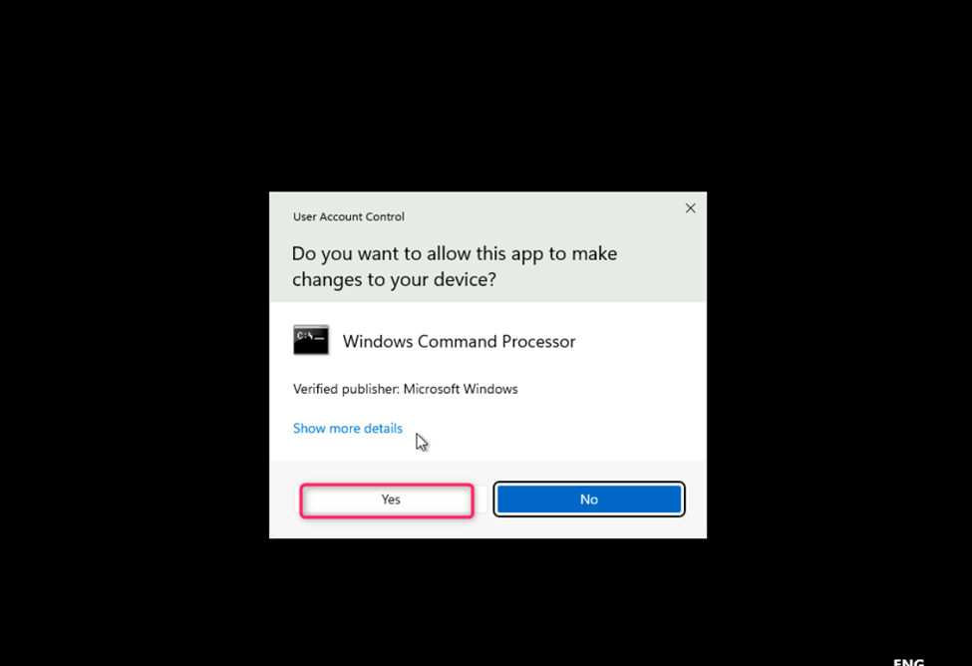

**Important Note**: You need to change the current directory to the **Labfiles** directory (The command used to move back to the previous directory is **cd .. [space after cd then two dots],** the command used to move to the next directory is **cd \)**

1. Change your directory to application directory using the following command as shown in the below image:

powershell

cd ..

powershell

cd Labfiles

1. In the **Command Prompt** windows execute the below command login to the Azure portal

powershell

azd auth login

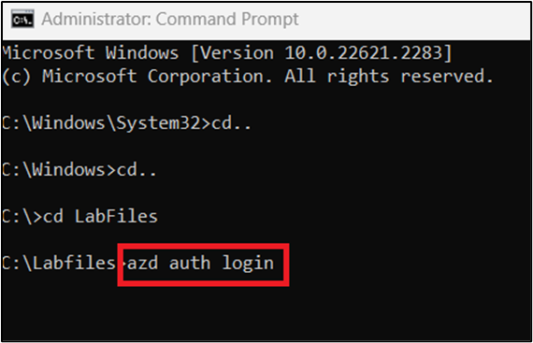

1. This command will take you to the default browser to login, use the Azure OpenAI Tenant credentials provided on the home tab of lab interface.

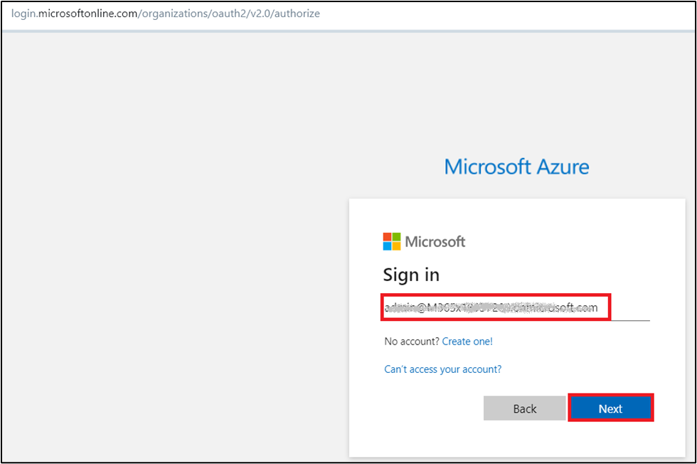

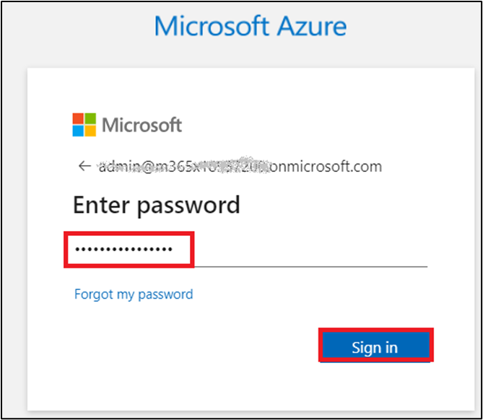

1. Once authenticated switch back to the Command prompt Window

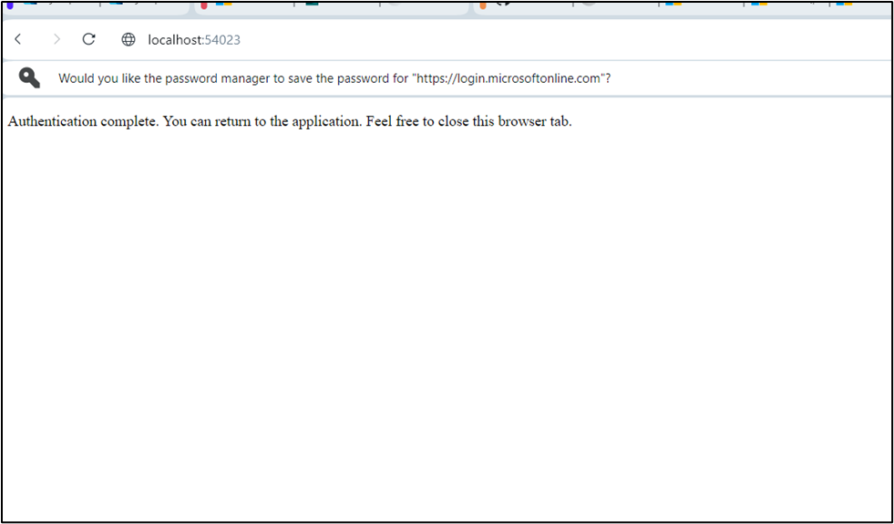

1. You should be able to see the below message in the Command prompt Window.

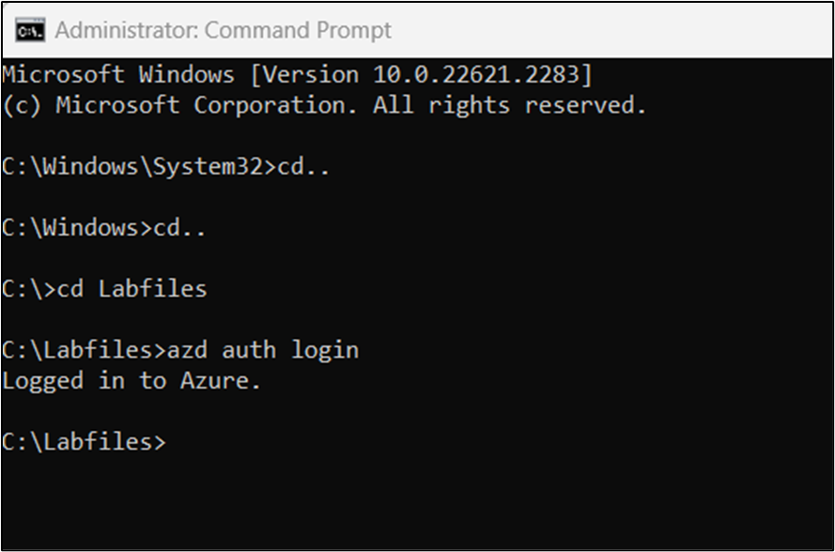

1. In the **Command Prompt** windows execute the below command to login to folder.

powershell

cd AzureOpenAIcustom

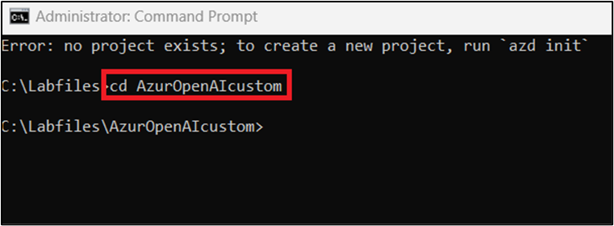

**Task 6: Deploying from scratch**

1. Execute the following command, this will provision Azure resources and deploy this sample to those resources, including building the search index based on the files found in the ./data folder.

powershell

azd up

1. You will be prompted to Enter a new environment name enter **AzureOpenAICutomKB** and Select **your azure subscription.**

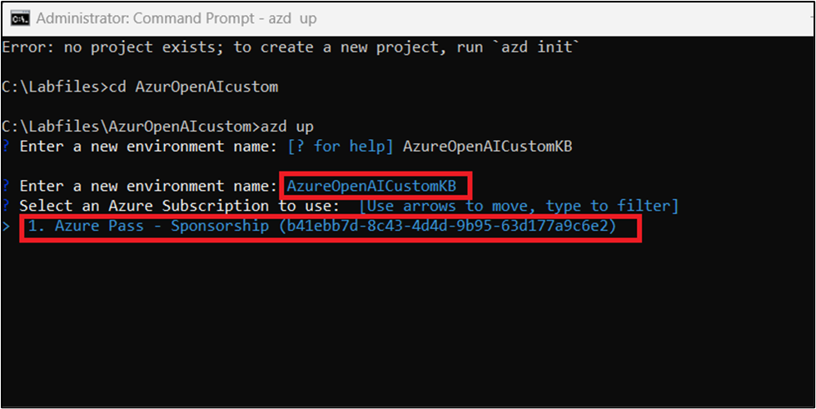

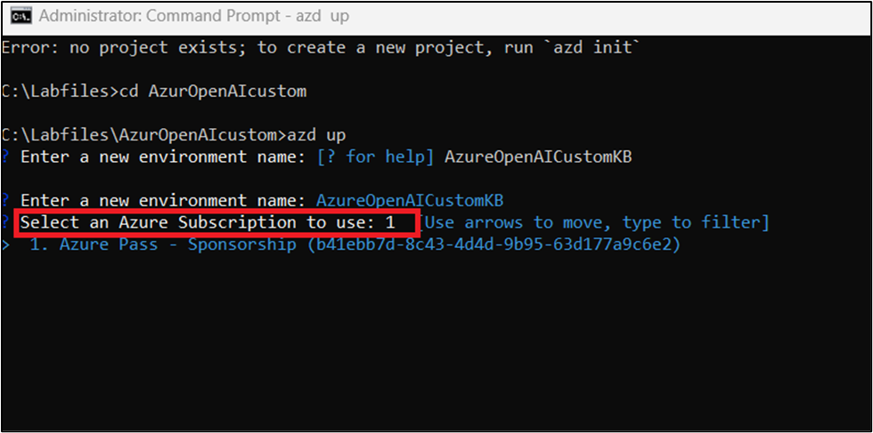

1. You will be prompted to **select an Azure location to use** then select **East US.**

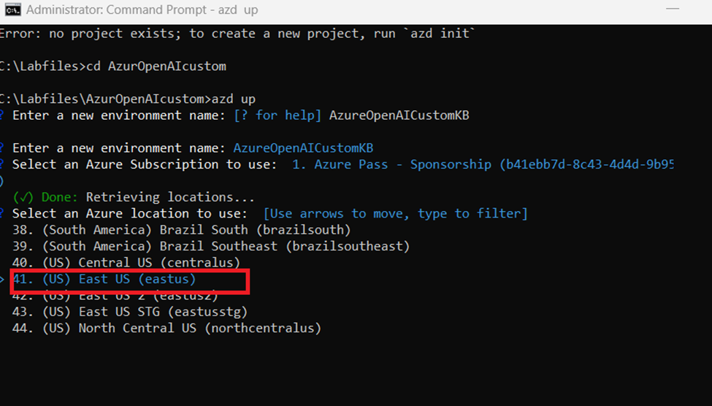

1. After the application has been successfully deployed you will see a URL printed to the **command prompt**. Click that **URL** to interact with the application in your browser.
2. The deployment will take around **20-25** min

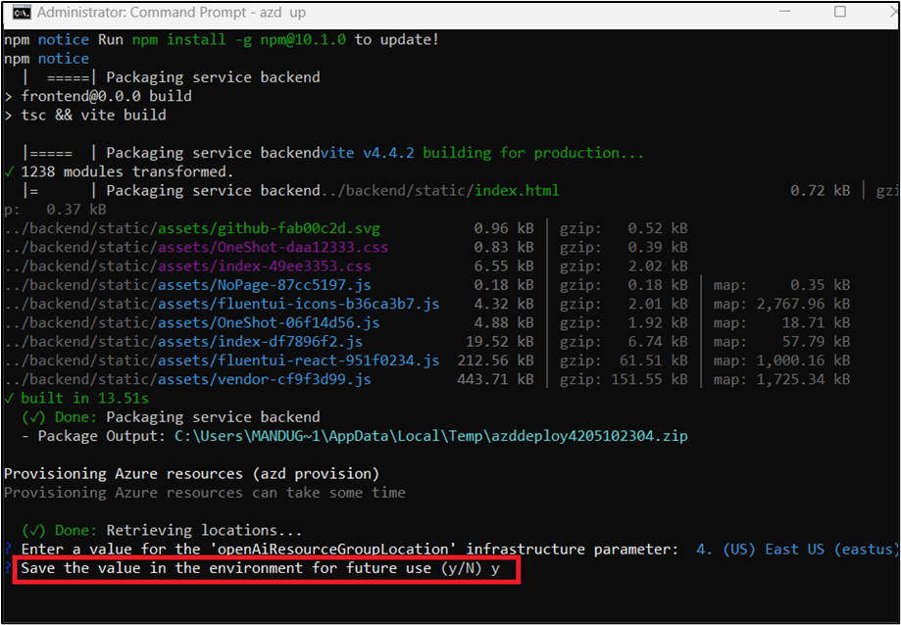

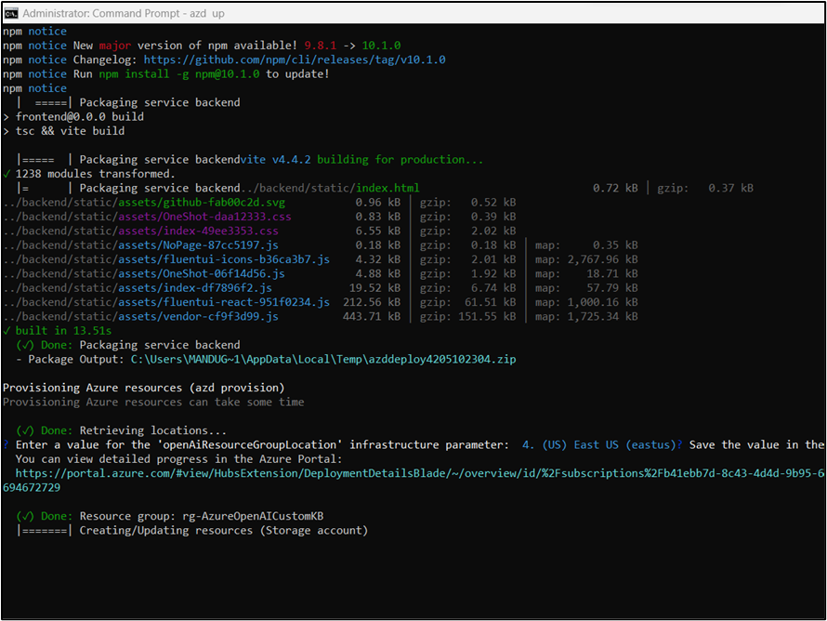

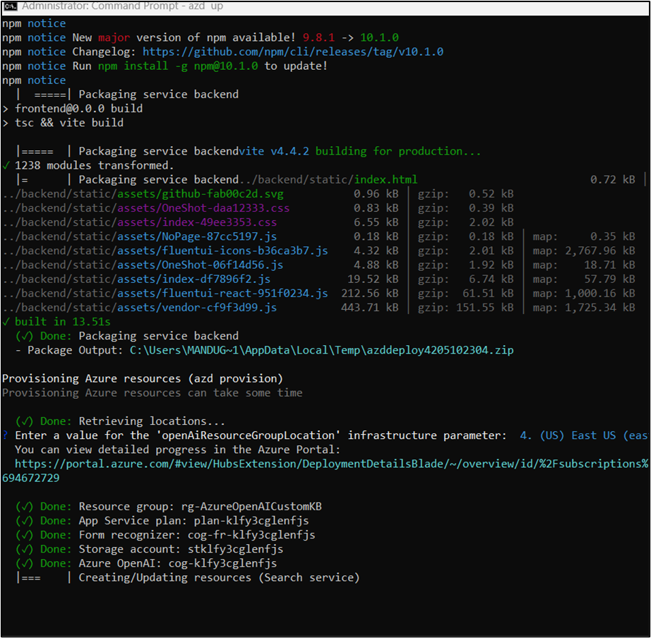

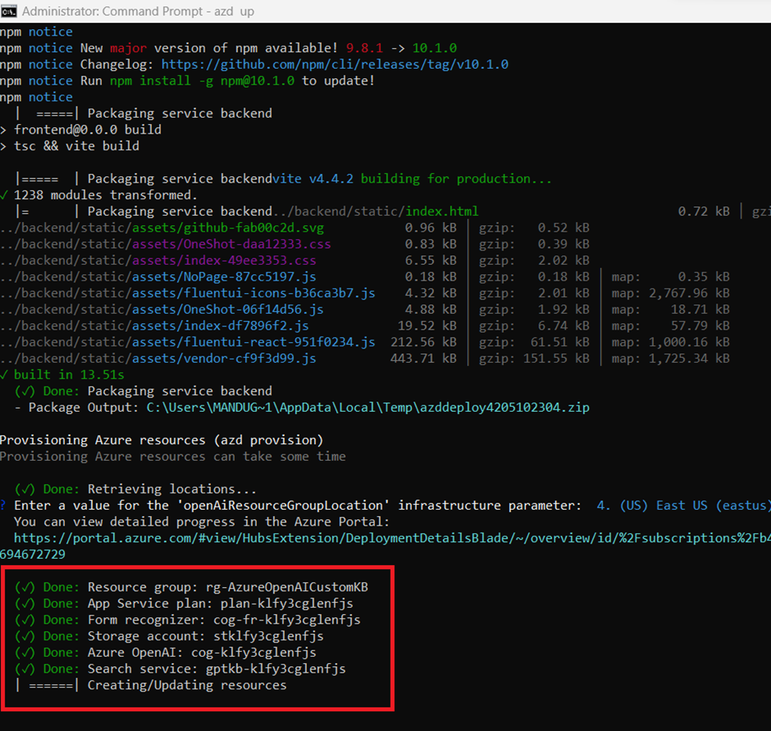

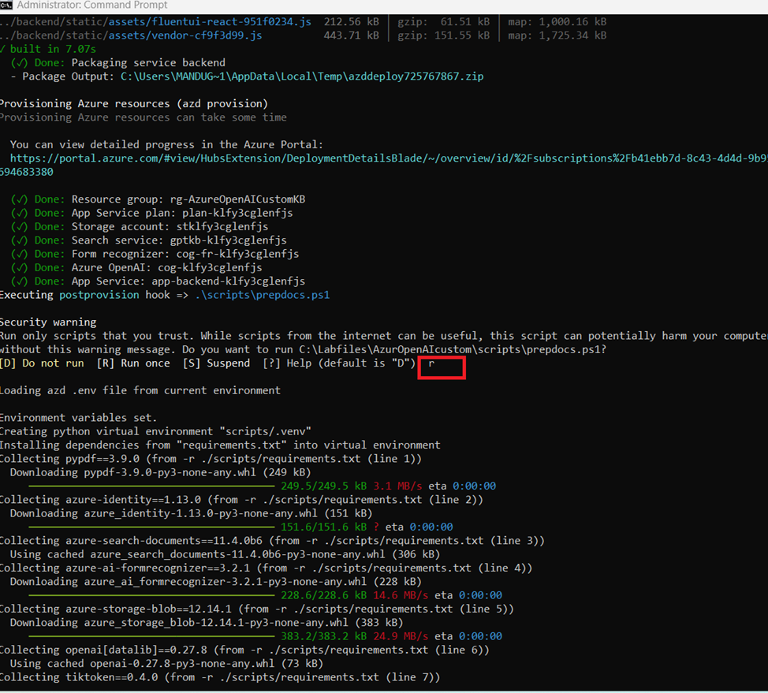

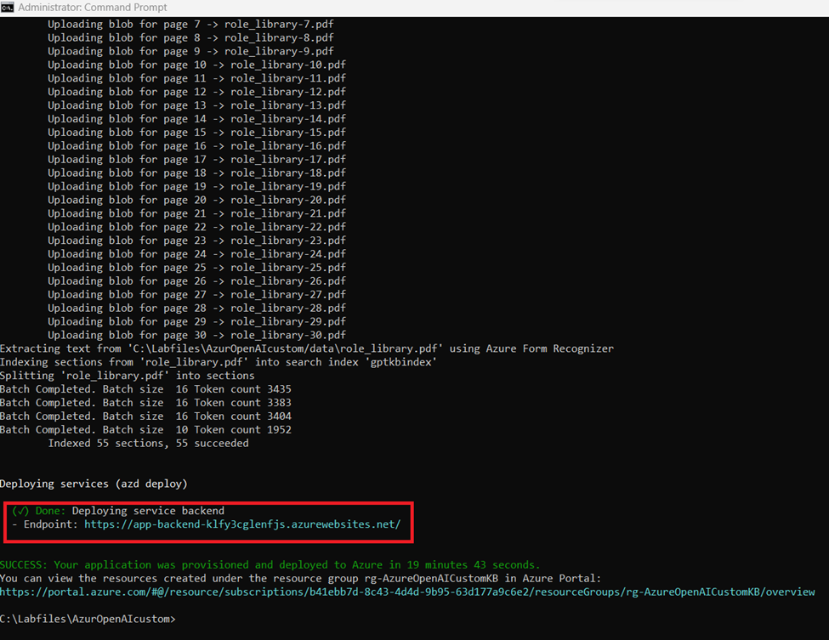

1. Click that URL to interact with the application in your browser

Example: <https://app-backend-klfy3cglenfjs.azurewebsites.net/>

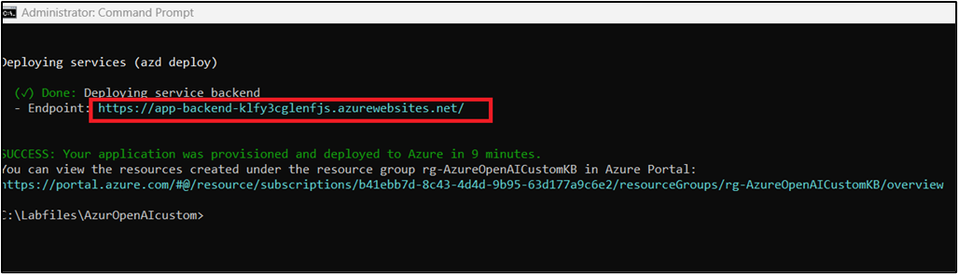

1. Now, application will open in a new browser.

<https://app-backend-klfy3cglenfjs.azurewebsites.net/>

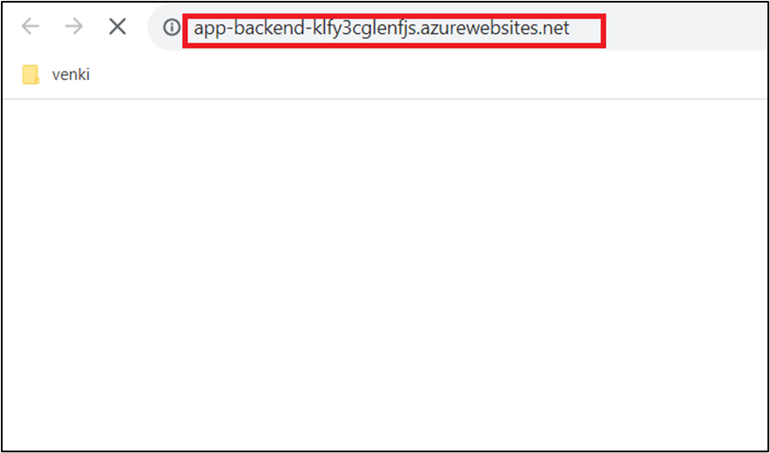

1. After 10 minutes, click on the **Refresh** button.

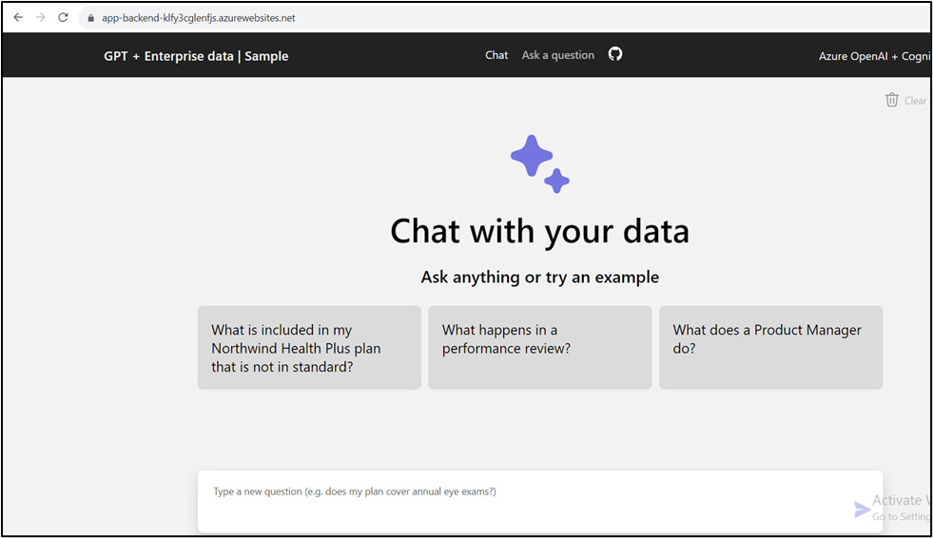

1. In the **GPT+Eneterprise data |Sample** web app page, enter the following text and click on the **Submit icon** as shown in the below image.

**Does my plan cover annual eye exams?**

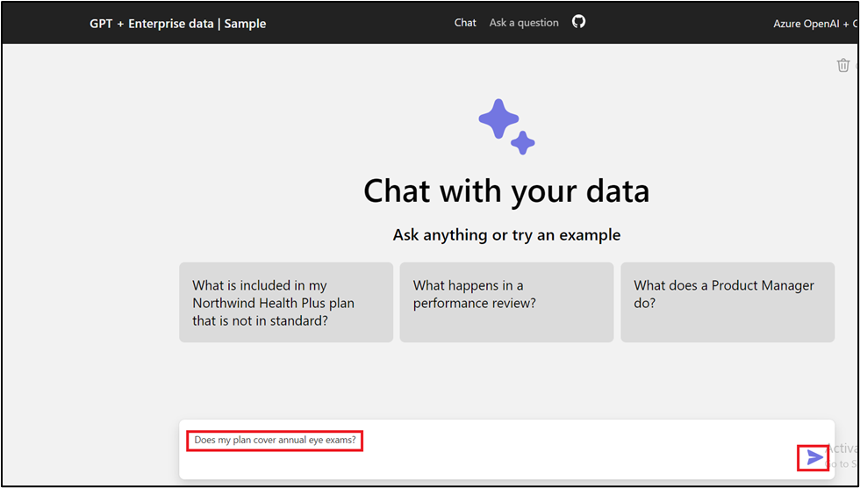

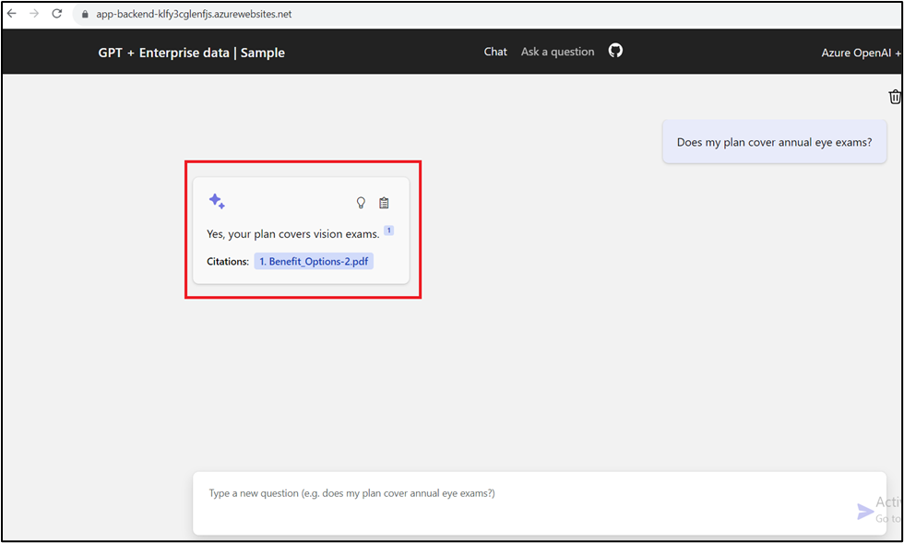

1. In the **GPT+Eneterprise data |Sample** web app page, enter the following text and click on the **Submit icon** as shown in the below image.

**Explain Northwind Health Plus**

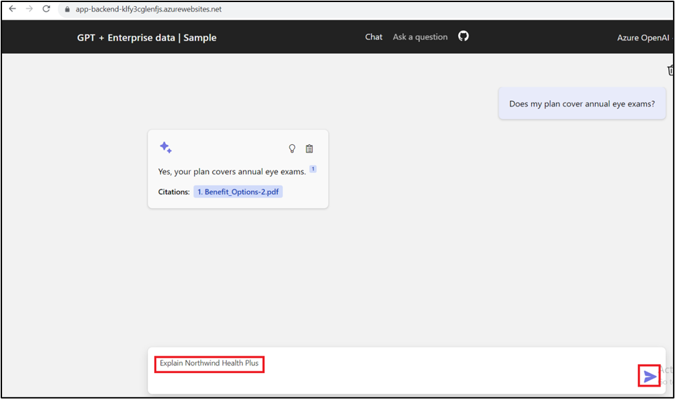

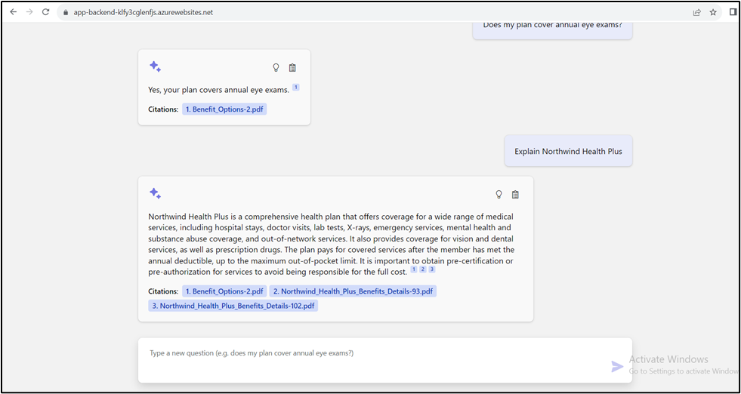

1. To verify new created resource, open your browser, navigate to the address bar, and type or paste the following URL: https://portal.azure.com/, then press the **Enter** button.



1. In the **Microsoft Azure** window, use the **User Credentials** to login to Azure.

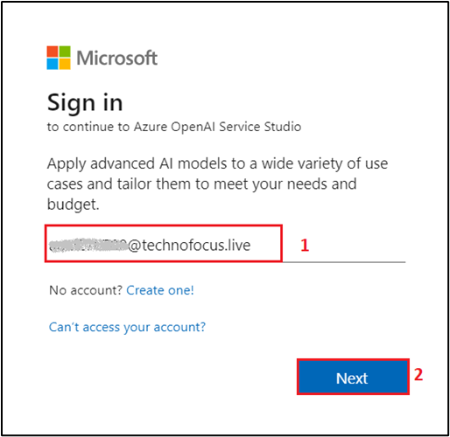

1. Then, enter the password and click on the **Sign in** button.



1. In **Stay signed in?** window, click on the **Yes** button.



1. Type in **Resource group** in the search bar and select **Resource group**.

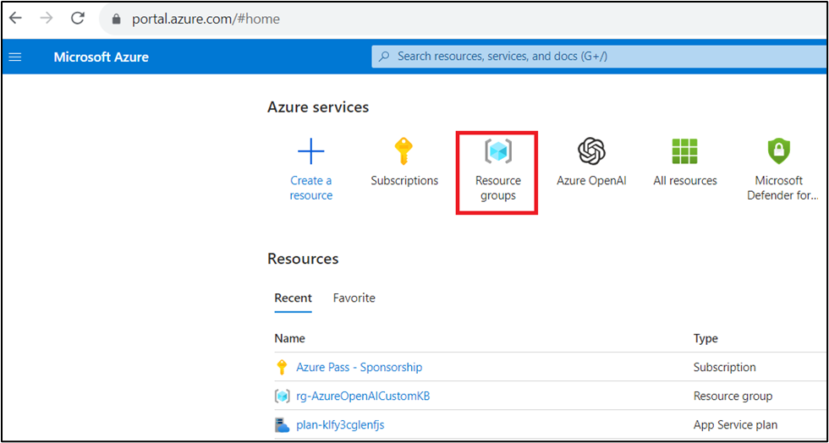

1. Select your new created **resource group**

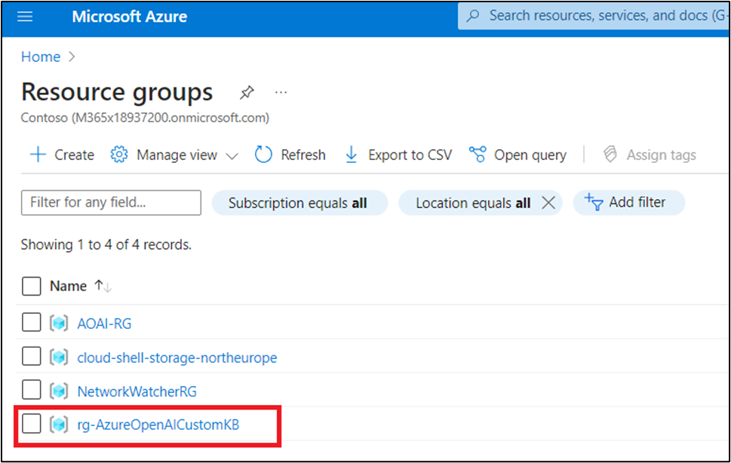

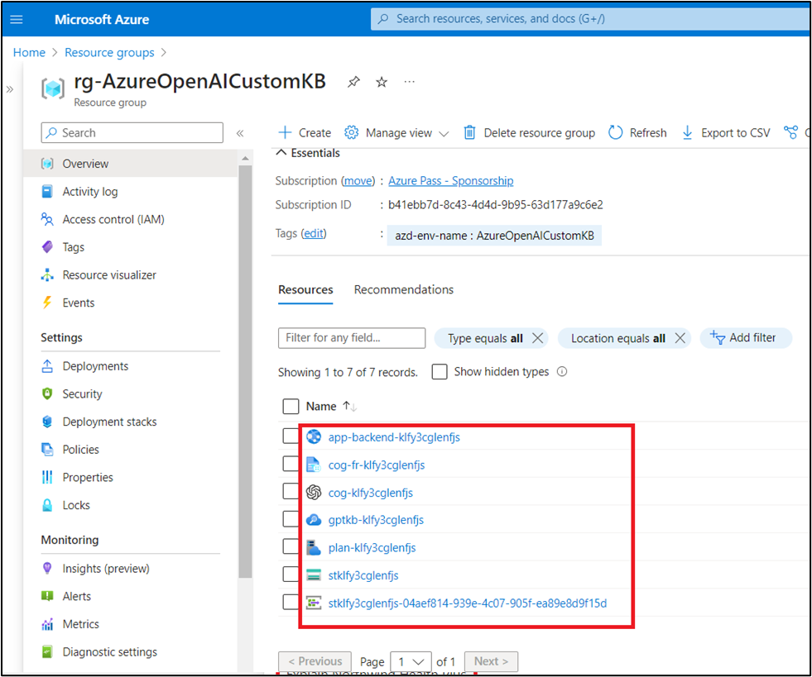

**Task 7: Delete the Resources**

1. To delete Resource group , type **Resource groups** in the Azure portal search bar, navigate and click on **Resource groups** under **Services**.

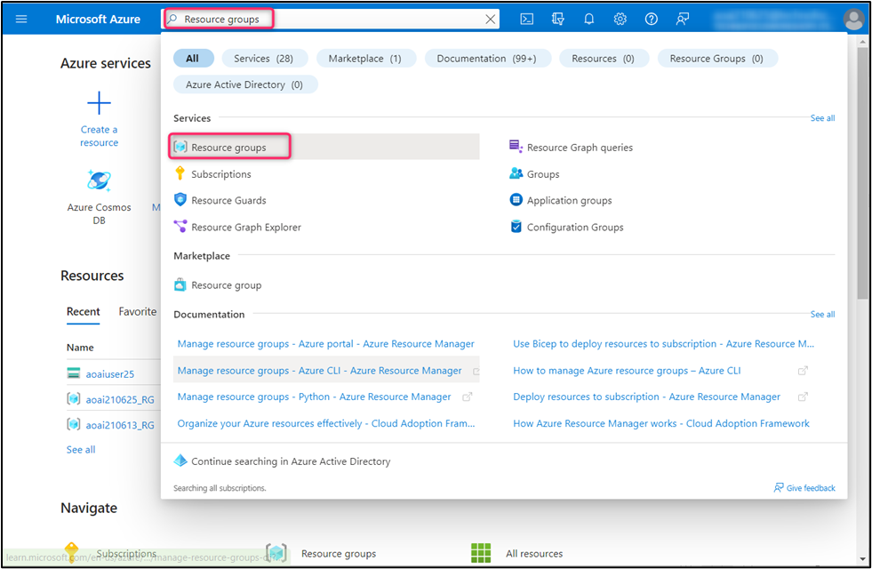

1. Click on the assigned resource group.



1. In the resource group home page , select **Delete resource group** button.

